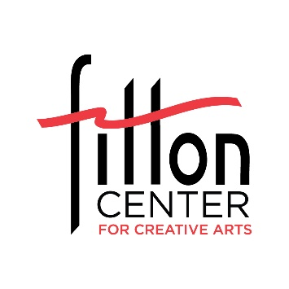
Community Gallery Application
Fitton Center for Creative Arts
Please complete and email to Cathy Mayhugh
at cathy@fittoncenter.org

Date of application:

Name of Group and full contact info of Group’s Exhibition Coordinator:
(include name, street address, city, state, zip, email address, mobile phone number):

Title of Project or Exhibition: ________________________________________

Please briefly describe your group and the art you plan to exhibit. Provide info in a way that will help us promote your exhibition on our website and social media.

Jpeg: Please email a jpeg image file of artwork or organization logo to represent the show on our website. Email to cathy@fittoncenter.org

Artwork series description: Please provide your best estimated description of the nature of the artwork to be displayed.
- total estimated number of artworks:
- estimated number of artists featured:
- How will wall works be prepared for display?
  - Are wall works framed, mounted, matted?
- If 3D artworks will be included, how many?
  - Are 3D works floor pieces or pedestal/display case pieces?

Would you like to offer any of the art for sale?

Timeline:

Is your group available to deliver and install the art on a weekday? If so, what day of the week would be ideal?

Are members of your group available to learn about exhibition design and presentation by helping with installation? (this is standard for Community Gallery programming and highly valued) If so, please provide the anticipated number of helpers.

Would you like to schedule a public reception event celebrating the exhibition? If so, please provide some potential dates/hours.

Would you like to plan a group field trip/s during the run of the exhibition? If so, what is an ideal day of the week and arrival time?

Cathy Mayhugh, Director of Exhibitions, cathy@fittoncenter.org 513 863 8873 ext. 122
Fitton Center for Creative Arts, 101 S. Monument Ave, Hamilton, Ohio 45011, 513 863 8873
fittoncenter.org

